## Correlation Analysis



The correlation matrix provides valuable insights into how different variables are interdependent with each other and to employee attrition. The positive correlation between attrition and overtime and distance from home suggests that employees who work overtime or live farther away from work are more likely to leave their jobs. On the other hand, the high correlation between percent salary hike and performance rating (0.77), as well as job level and monthly income(0.95), suggests that employees who perform well, have higher job levels and salaries, and receive regular salary hikes are more likely to stay in their jobs. (Grissom & Mitani, 2016).

Based on the high positive correlation between percent salary hike and performance rating, it can be inferred that employees who receive higher performance ratings (0.77) are more likely to receive a higher percentage of salary hike. This suggests that performance is a critical factor in determining salary hikes within the organization.

Additionally, the correlation between job level and monthly income (0.95) indicates that employees who hold higher positions within the company tend to have a higher monthly income. This suggests that the company has a clear hierarchy and rewards employees for their seniority and job level.

Furthermore, the correlation between years at the company, years in a current role(0.76) , years since the last promotion, years with the current manager(0.51), and total working years(0.63, 0.46, 0.40, 0.46 respectively) suggests that employees who have spent more time in the company and have had longer tenures in their current roles are less likely to leave the organization. This suggests that the company values employee loyalty and longevity, and rewards it with career growth opportunities and job security. These inferences suggest that the company has a structured hierarchy, values employee loyalty and performance, and rewards them accordingly.

## REGRESSION ANALYSIS

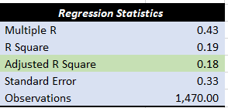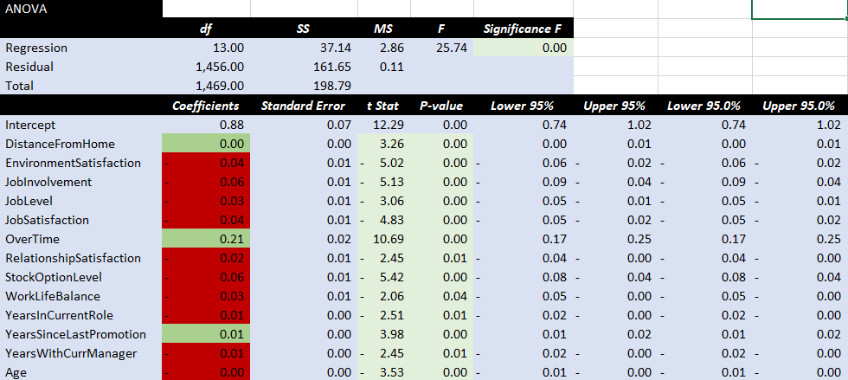

An adjusted R-squared value of 0.18 means that the predictor variables in the regression model explain 18% of the variance in the response variable after adjusting for the number of predictors in the model.This suggests that the model may not be a good fit for the data, and there may be other factors that are influencing the response variable that are not captured by the predictor variables in the model.

How ever predictive variable has significant relationship with the dependent variables. Job involvement, age, job satisfaction, job level, work life balance, stock level option, years with manager all these shows negative association with the Attrition rate it means the lesser these factors there will be more likely the attrition. The higher these factors less likely for employees to leave the job. While over time variable shows positive association means the more employees work overtime, they may be less compensated and more likely to leave the job.

# **Recommendations**

1. As we can see, job satisfaction is a major factor in employee retention. To address this, company can create a positive work environment, recognizing and rewarding employees for their hard work, and providing opportunities for career growth and development.
2. Work-life balance is another important factor in employee satisfaction. This can be addressed through offering flexible working arrangements, such as telecommuting or flexible hours, and encouraging employees to take time off when needed (Shagvaliyeva & Yazdanifard, 2014)
3. As we can see, higher salaries and stock options are associated with lower attrition rates. Competitive salaries and benefits packages can be a powerful tool to attract and retain young employees. Offering flexible work arrangements, such as remote work options can also appeal to older workers' desire for work-life balance.
4. Providing training and development opportunities can help employees feel more engaged and invested in their work. investing in training and development programs to help employees develop new skills and advance their careers can reduce attrition rates significantly. Training time of 2-3 hours would be best while keeping the quality of training and engaging in mind.
5. Providing opportunities for career advancement is important for employee retention. Young employees are often eager to learn and grow in their careers. By providing clear career paths and promoting employees from within would be beneficial as new employees have a high likelihood to leave.
6. Employees who have a good relationship with their managers are more likely to stay with the company. Young employees want to feel valued, supported, and included in the workplace. If their relationship satisfaction grows and becomes a valuable factor in leaving the job, they may reconsider leaving. Employers can create a positive work culture by providing opportunities for socialization, recognition, and feedback. investment in developing effective leadership skills is needed in the managers to encourage open communication and feedback between employees and their managers.
7. Regular communication and feedback can help build trust and engagement among younger workers. Employers/Manager can establish an open-door policy, conduct regular check-ins, and solicit feedback from young employees to ensure they feel heard and valued.
8. Conducting exit interviews with employees who leave can help identify areas for improvement and help the company develop targeted retention strategies for the 18-26 age group and Sales and HR departments.